FINANCIAL MODELING, 3rd edition
Allowing Macros to work
This version: December 19, 2008

Files with Financial Modeling contain small VBA programs (“macros”)—these must be enabled. This short document discussed how to enable the macros.

Implementing macros
When opening a spreadsheet, you will be confronted by a screen asking if you want to enable the VBA programs on the file. All files have Getformula embedded; some files have other VBA programs also.
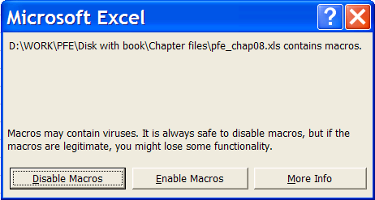  Excel 2003 screen | 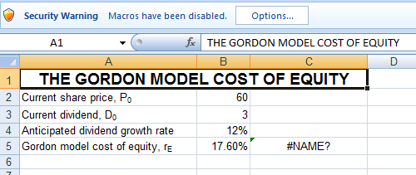  Excel 2007: Clicking on the Options box leads to this screen.  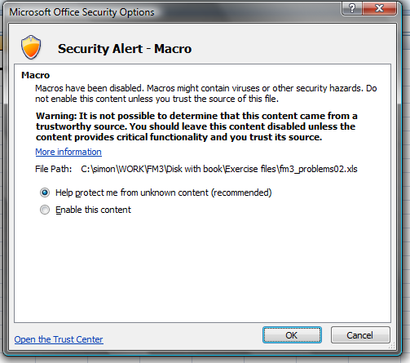

If you are opening files from the FM3 disk, you can safely click the Enable button: This enables a small program called Getformula which helps identify the cell contents. There may be other macros on the files also.

Changing the security settings: Excel 2003
If you get the message below when opening a FM3 file, you will need to reset your security settings to enable Getformula to work:
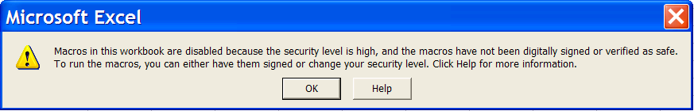
If you get this message, click on Tools|Macro|Security:
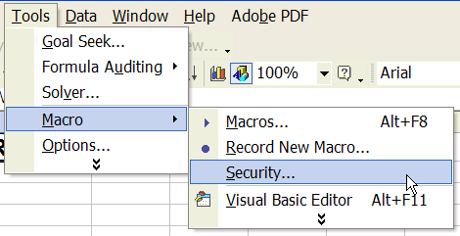

Reset the Security setting to Medium:
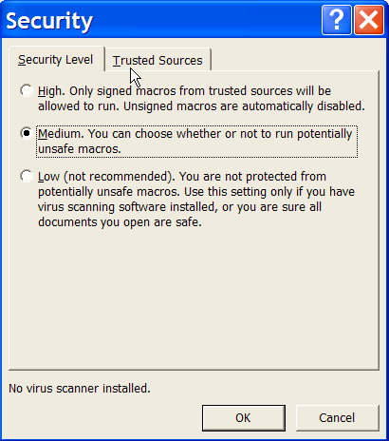
Changing the security settings: Excel 2007
Here are the instructions to change the security settings in Excel 2007:
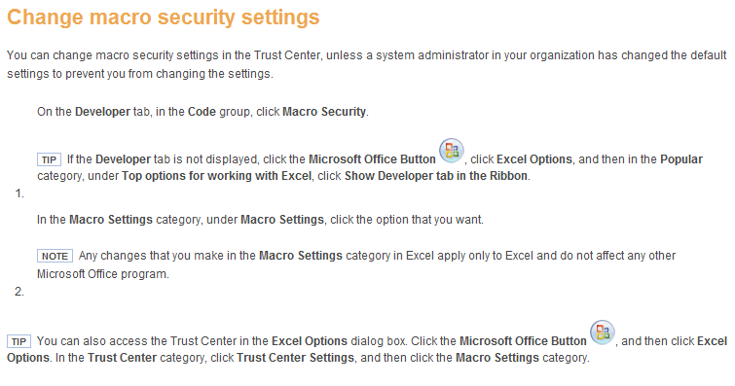

Enjoy!
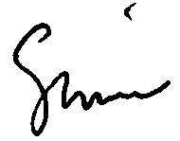
Simon Benninga
Benninga@wharton.upenn.edu

